UUH General TeleHealth Resources:
Resources For Conduction TeleHealth Visits
This site has the most up to date information on UUH Telehealth resources and should be referenced for any questions. You access this site from the main Pulse page (https://pulse.utah.edu) and clicking on the the permanent gray “COVID-19 Resources” ribbon:

You will need to log on with your uID and password to access Pulse.

The UUH Telethealth Resources are under the “Clinical Information” column
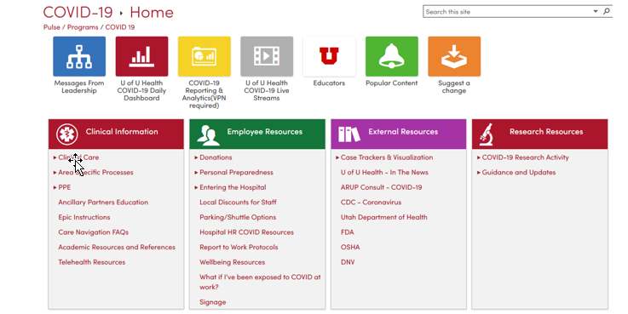

Telehealth Overview Videos:
University of Utah TeleHealth LMS Training
Link to Powerpoint????

TeleHealth Guides and Tips:
In depth guides are tip sheets for conducting virtual visits are listed under the Virtual Visit Training and Tip Sheets section under the Telehealth Resources link in Pulse discussed above.

Zoom Set Up Tips:
Selecting a Professional Virtual Background (Zoom)
TeleHealth Backgrounds for Zoom

This list is based on resources thoughfully gathered by the Rural and Underserved Utah Training Experience (RUUTE) Undergraduate Medical Education Team.

